How to make a gridded self portrait:

On your photogragh:
1.Don’t for get to number your grid along the top and down the side.
2. Trace the contour of outside yourself in the photograph. You can even trace the shape of your head

On the 12”X16” Paper:
- On 12”X 16” paper make 1 inch border from the bottom and top and an 1 inch border along the sides.
- Lay ruler along the top of the paper and draw a hash mark for each inch inside of the border. Do this on all four sides.
- Draw straight lines from top to bottom and side to side of each hatch mark so that you have a grid.
- Number along the sides and the top.

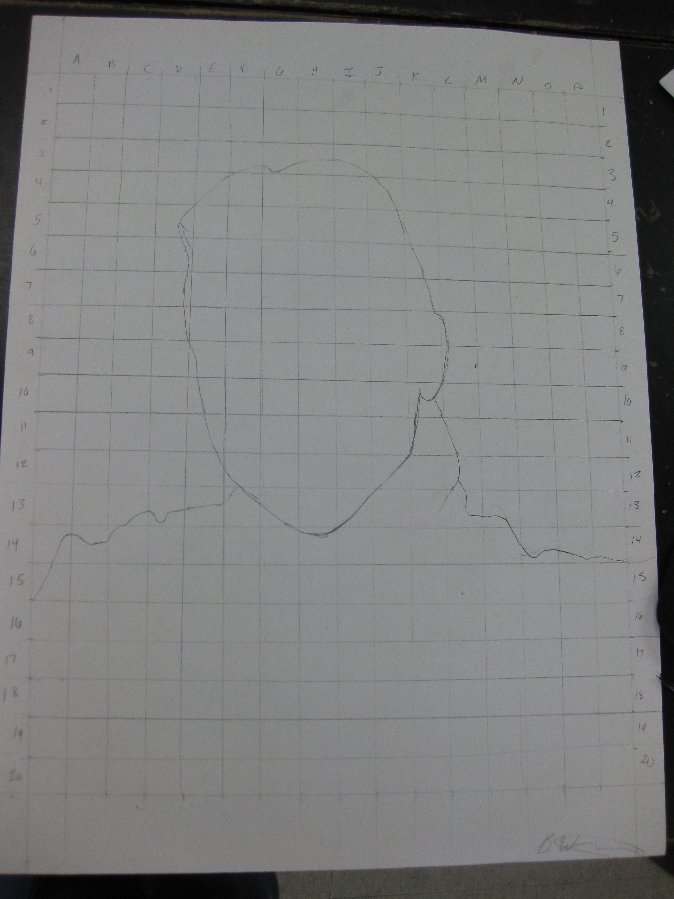
Getting Started Drawing:
- Begin by drawing the outside contour line on your photograph onto the 12”X16” paper, then draw the shape of your head, lightly draw in the shapes of your facial features– see hand out
- Then go from square to square, drawing what is in each.
- You will want to draw the shapes, lines and values that you see in each square- use the handouts for your eyes, nose, mouth, etc. to help you.

A few tips:

YOU CAN DO THIS!!!! YOU ARE AWESOME AND NOW HAVE THE SKILLS TO MAKE A REALISTIC POTRAIT!!!

- Value is your friend: look at your portrait and identify the areas that have the same values. For examples- where your lips meet and the pupil of your eye will probably be your darkest value. The catch light of your eye and high light on your lower lip with probably be the lightest.
- Do not use hard lines on any facial features…with the exception being your eyes or if you wear glass.
- Treat each box like one of your warm up and draw what you see!
- Every so often turn your photo and your paper. This is so that you are drawing with the right side of your brain and are less tempted to draw the symbol for the facial features. In this way you will be more focused on the shapes and values rather than their actual facial features

